SUTD 50.001 Introduction to Information Systems and Programming
Problem Set 2A
Note:
- For all questions, please access the vocareum link found at eDimension for the starter code and to submit.
- You are reminded to submit your answer in the work folder in Vocareum.
- The Vocareum link is for submission only. Please work on the problems in Android studio, and this includes writing code for the test cases.
- To prevent hard-coding, test cases used in Vocareum may be different from those provided here and will not be given to you.

We thank UTAs Cai Junjie, Dinh Thao Vy and Yang Si Jun for their help in checking this problem set, correcting typos and providing suggestions for improvement.

1. [15 points] Title Abstract Class
Concept Check.
Before you start coding, think about the following:
- What is an abstract class? How does it differ from a concrete class? How is it similar to a concrete class?
- Are you able to instantiate an abstract class? Why?
- As a writer of a class, what must you do in a concrete subclass of an abstract class?
- In what situation would a programmer choose to write an abstract class?

You are given the following abstract class GeometricObjectMod. The designer of this class envisions that all subclasses will represent different shapes, and all of them will have attributes colour and be filled or not. All the shapes also have an area and perimeter. However, clearly the calculation of the area and perimeter are different between shapes.
public abstract class GeometricObjectMod {
private String colour;
private boolean filled;
GeometricObjectMod(){
colour = "white";
filled = false;
}
GeometricObjectMod(String colour, boolean filled){
this.colour = colour;
this.filled = filled;
}
public abstract double getArea();
public abstract double getPerimeter();
public String getColour() {
return colour;
}
public boolean isFilled() {
return filled;
}
}

Next page

Write a concrete class Triangle that is a sub-class of GeometricObjectMod. The constructor of Triangle is given to you – it takes in three double values representing the three sides of a triangle. Please note that the triangle is not necessarily a right-angled triangle. It also initializes the instance variables filled and colour with their default values using the superclass constructor. Search online for Heron’s formula to calculate the area of a triangle from the length of three sides.
public class Triangle {
private double a;
private double b;
private double c;
Triangle( double a, double b, double c){
this.a = a;
this.b = b;
this.c = c;
}
}

Test cases (not exhaustive, write your own).
GeometricObjectMod triangle = new Triangle(3.0, 4.0, 5.0);
System.out.println(triangle.getArea()); // 6.0
System.out.println(triangle.getPerimeter()); // 12.0
System.out.println(triangle.getColour()); // white

Concept check

You would like two Triangle objects to be considered equal if their values of a,b and c are the same, or if they are aliased. What method(s) would you implement or override in the Triangle class?

2. [20 points] Title: Interfaces
Concept Check.
Before you start coding, think about the following:
- How is an interface different from an abstract class?
  - Can you write a constructor in an interface?
  - Can you write an instance variable in an interface?
  - What are other differences?
- Do you need to specify the public modifier for an abstract method in an interface? Why?
- In what situation would a programmer choose to write an interface?
- If you write a class that implements Dog, provide an implementation of makeSound() but choose to retain wagTail() as an abstract method, then what must you declare the class as?

Going Further (optional)
- The features defined for interfaces in Java 8 are sufficient for a strong understanding of the purpose and benefits of interfaces.
- You may want to read up about the revisions to the interface from Java 9 onwards.

You are given the following interface Dog. The programmer envisions a family of Dog classes, all of which have the same behaviour i.e. makeSound and wagtail.
In other words, the programmer wants a guarantee that, for an object of any class that implements the interface Dog, it is able to execute a makeSound() and wagTail() method.
public interface Dog {
String makeSound();
String wagTail();
}

Next page

Write two concrete classes Husky and Retriever, both of which implement Dog.
The constructor of Husky and Retriever each take in and initialize a private String instance variable name.
public class Husky{ // same for Retriever
private String name;
Husky(String name){
this.name = name;
}
}

Suppose the name passed to the constructor is Fido. The following table summarizes what string each of the methods should return. There is one blank space between words and there are no leading/trailing spaces.
 | Husky | Retriever
makeSound() | Fido howls | Fido says woof
wagTail() | Fido wags tail | Fido moves tail

Test cases (not exhaustive, write your own)
Dog dogHusky = new Husky("Mr White");
System.out.println(dogHusky.makeSound());
System.out.println(dogHusky.wagTail());
Dog[] dogs = { new Husky("Fido"), new Retriever("Buddy") };
for (Dog dog : dogs) {
System.out.println(dog.makeSound());
System.out.println(dog.wagTail());
}
// TODO As an exercise, rewrite the code above using an ArrayList

Output
Mr White howls
Mr White wags tail
Fido howls
Fido wags tail
Buddy says woof
Buddy moves tail
3. [10 points] Title: Comparable interface
Given the following Octagon class, which represents a regular octagon (all sides equal):
public class Octagon {
private double side;
public Octagon(double side){
this.side = side;
}
public double getSide() {
return side;
}
}
Modify this Octagon class to implement the Comparable<Octagon> interface to allow sorting of Octagon objects based on their perimeters.
An Octagon class implementing the Comparable<Octagon> interface allows a List of Octagon objects to be sorted by a natural ordering (in this case, the perimeter). This is demonstrated in the following Test code:
public class Test {
public static void main(String[] args) {
ArrayList<Octagon> l = new ArrayList<Octagon>();
l.add(new Octagon(2));
l.add(new Octagon(3));
l.add(new Octagon(1));
Collections.sort(l);
for (Octagon o:l)
System.out.println(o.getSide());
}
}
Results:
1.0
2.0
3.0

4. [10 points] Title: Comparator interface
Given the following Octagon class, same code and assumptions as previous question:
public class Octagon {
private double side;
public Octagon(double side){
this.side = side;
}
public double getSide() {
return side;
}
}
Implement a OctagonComparator class to implement the Comparator<Octagon> interface to allow sorting of Octagon objects based on their perimeters.
In this case, the Octagon does not implement any interface. You design a separate class called OctagonComparator which implements the Comparator<Octagon> interface. The OctagonComparator class specifies how a List of Octagon objects is sorted (in this case, the perimeter) and an object of this class is passed to the Collections.sort() method. This is demonstrated in the following Test code:
public class TestOctagonComparator {
public static void main(String[] args) {
ArrayList<Octagon> l = new ArrayList<Octagon>();
l.add(new Octagon(2));
l.add(new Octagon(3));
l.add(new Octagon(1));
Collections.sort(l, new OctagonComparator());
for (Octagon o:l)
System.out.println(o.getSide());
}
}
Results:
1.0
2.0
3.0
Concept check

Go back to the Triangle class. Suppose you want the ability to sort Triangle objects by their area or by their perimeter. Would you choose to
- have the Triangle class implement the Comparable<T> interface?
- Write Comparator<T> classes for each method of sorting (i.e. one class for sorting by area, one class for sorting by perimeter?)

5. [15 points] Title: List of PrimeNumbers
Among others, ArrayList<T> and LinkedList<T> are concrete implementations of the List<T> interface. Since the List<T> interface specifies abstract methods add(), get() and so on, you have the guarantee that for an ArrayList<T> object or LinkedList<T> object, you are able to execute the methods add() and get() .
Thus, in the method getPrimeNumbers() below, since the return type is List<Integer>, you have the choice of returning either a ArrayList<Integer> or LinkedList<Integer> object or any other object that implements the List<T> interface.
In the class Sieve, write a static method getPrimeNumbers that returns any List<Integer> object (i.e. ArrayList<Integer> or any other ) that contains all the prime numbers from 2 up to and including n. Assume that 2 ≤ n ≤ 100.
public class Sieve {
public static void main(String[] args) {
List<Integer> list = getPrimeNumbers(25);
System.out.println(list); // [2, 3, 5, 7, 11, 13, 17, 19, 23]
}
public static List<Integer> getPrimeNumbers(int n){
}
}

You are free to
- define any other static method in Sieve to help your implementation. Only getPrimeNumbers() is executed by our autograder.
- use any algorithm you like to generate the prime numbers.
For an efficient algorithm, you may consider using the Sieve of Eratosthenes.
Read more here.

6. [Total: 20 points]
Develop the software using inheritance and interfaces as shown in the following figure. Note that an arrow from P to Q means that P is a subclass/sub-interface of Q, or P implements Q.
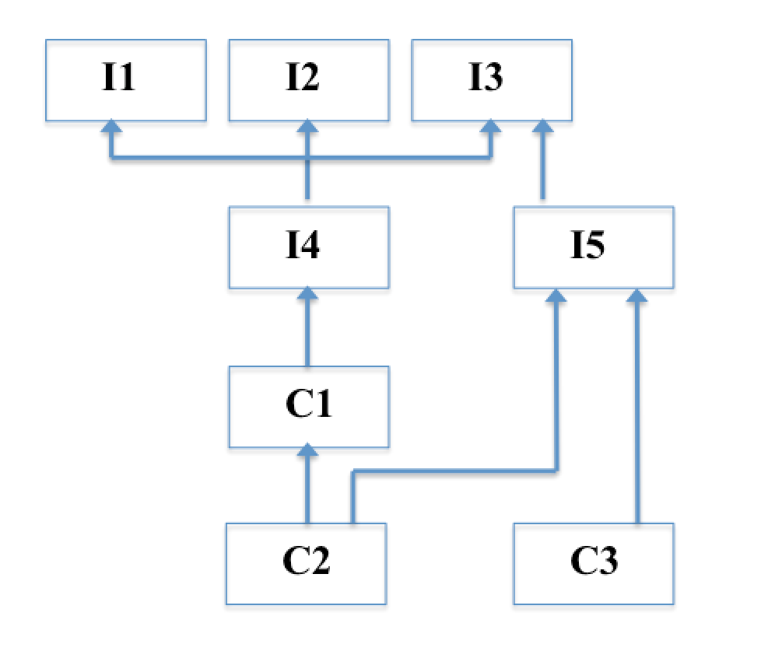
Interface I1 contains a method int p1();
Interface I2 contains a method int p2();
Interface I3 contains a method int p3();
Interface I4 contains a method int p4(); Note that I4 also inherits accessible programming constructs from I1, I2, I3, as shown in the figure.
Interface I5 contains a method int p5();
Class C1 contains only an abstract method int q1(); Note that C1 also implements I4 as shown in the figure.
Class C2 is a concrete class and provides all the needed implementations of methods. All the implementations simply return 0.
Class C3 is a concrete class and provides all the needed implementations of methods. All the implementations simply return 0.

7. [20 points] Title: Recursion
The recursive algorithms for determining whether a string is a palindrome and for calculating a factorial should be familiar to you by now.
Complete the static methods to implement the recursive algorithms for these static methods. You are free to use this question to explore other solutions for these problems.
public class Recursion {
public static void main(String[] args) {
System.out.println(isPalindrome("abca")); // false
System.out.println(factorial(5)); // you should know!
}
public static boolean isPalindrome( String s ){
}
public static int factorial( int n){
}
}

8. [Total: 30 points] Permutation.
A class Permutation takes in either a String or an int at its constructor and initializes the in instance variable. You can assume that the String object has a maximum length of 5 and has distinct characters i.e. no two characters are identical. You can assume that the int value is 0 or positive and has at most five digits. Similarly, all digits are distinct.
import java.util.ArrayList;
import java.util.List;
public class Permutation {
private final String in;
private final List<String> a = new ArrayList<>();
// additional attribute if needed
Permutation(final String str){
in = str;
}
Permutation(int number){
// complete this constructor correctly
}
public Permutation permute(){
// produce the permuted sequence of 'in' and store in 'a', recursively
permuteString(in, 0);
return this;
}
private void permuteString(String s, int i){
}
private String swap(String s, int i, int j){
}
public List<String> getA(){
return a;
}
}

The client of this class calls the permute() method to generate all the permutations of the characters in String or the digits in int, which is stored in the instance variable a. Then by calling getA(), a List object containing all the permutations is obtained. Note that permute() returns this, which is a reference to the current object, and doing so enables code to be written as shown in the example below.
The list of permutations can be in any order e.g. 645 can be the element at index 0.
List<String> list2 = new Permutation("hat").permute().getA();
System.out.println(list2);
List<String> list3 = new Permutation(456).permute().getA();
System.out.println(list3);

//[hat, hta, aht, ath, tah, tha]
//[456, 465, 546, 564, 654, 645]

If permute() is not called first, then getA() returns an empty List object.
List<String> list1 = new Permutation("hat").getA();
System.out.println(list1);
// []
Your task in this question is to complete the constructor Permutation(int number) so that in is initialized. E.g. Permutation( 123) means in is assigned to “123”.
You are also to complete the private methods permuteString() and swap().
Here is one possible algorithm for permuteString(). You are free to explore other algorithms, our autograder is unable to call private methods directly.
permute String s from position i is solved as follows
n is the length of s
if i is equal to n, append s to a
else
for index j from i to n-1 both values inclusive
swap elements i and j of s and assign the result back to s
permute s from position i+1
swap elements i and j of s and assign the result back to s

For swap() , obtain a char array from s, then swap the characters at position i and j. Lastly, create a new String with the result, and return it.

9. [10 points] Exceptions.
You are given two static methods with identical code. The code is meant to take in a String representing a file name, open that file and concatenate its lines into a string.
In readLineFromFileOne(), put a try-catch block around the appropriate line(s) of code. If there is no exception thrown, the method should return the string out. If an exception is thrown, return the output of the getMessage() method of the exception object. Remember that the catch block should catch FileNotFoundException.
In readLineFromFileTwo(), modify the header to specify that FileNotFoundException is thrown. You do not need to modify any other code .
If you are doing this exercise in your local computer,
- Create a text file in the same package as your code and type something in it.
- You may need to specify the entire absolute path of the text file.
In Android studio, right-click on the file, select Copy Path/Reference, select Absolute Path and paste it at the appropriate location in your code.
import java.io.*;
import java.util.Scanner;
public class TestExceptions {
public static void main(String[] args) {
System.out.println( readFileByLineOne("apple"));
try{
System.out.println( readFileByLineTwo("apple"));
}catch(FileNotFoundException ex){
ex.printStackTrace();
}
}
public static String readFileByLineOne(String filename){
File file = new File(filename);
Scanner scanner = new Scanner(file);
String out = "";
while(scanner.hasNext()){
out = out + scanner.next();
}
scanner.close();
return out;
}
public static String readFileByLineTwo(String filename) {
File file = new File(filename);
Scanner scanner = new Scanner(file);
String out = "";
while(scanner.hasNext()){
out = out + scanner.next();
}
scanner.close();
return out;
}
}

